LAB 3

1. Creating repository
2. Click on new

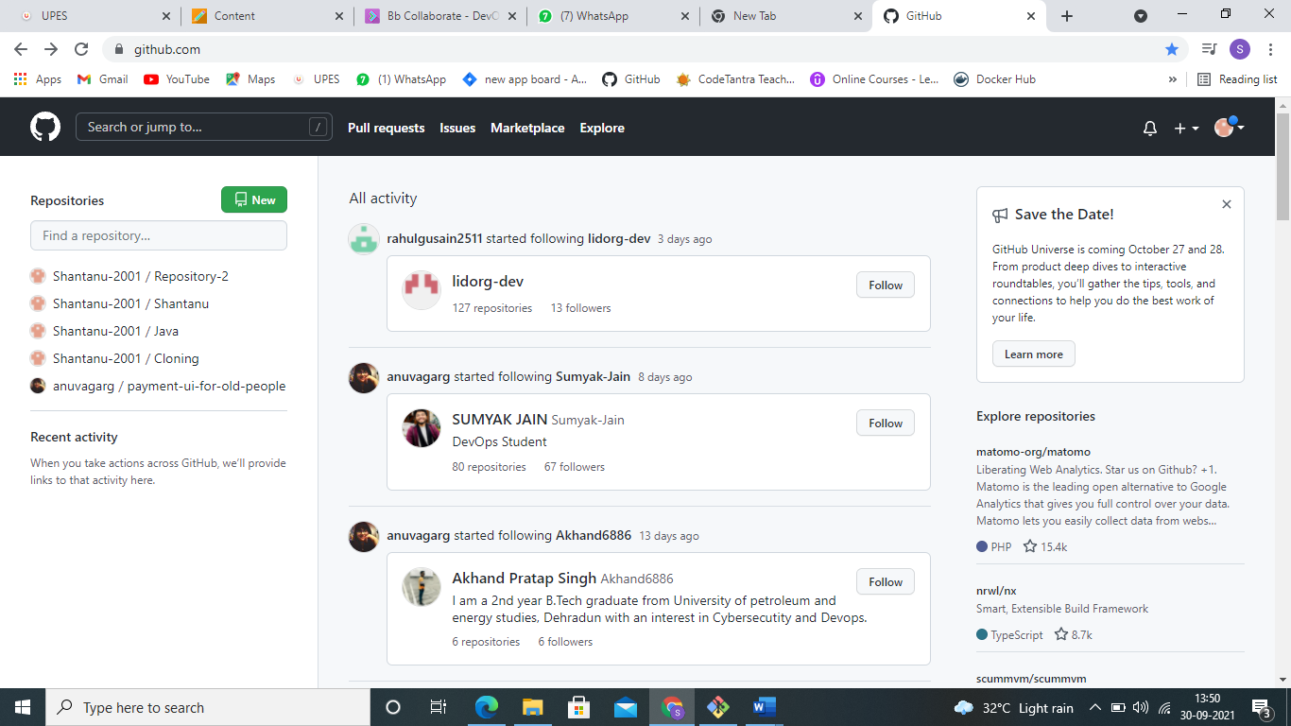

1. Then give a name to repository

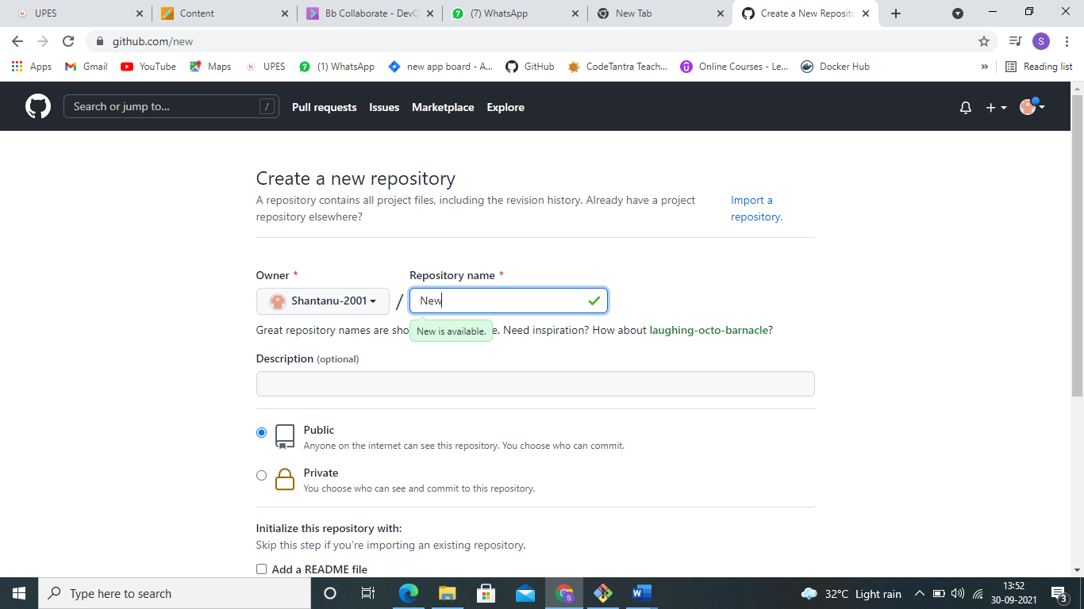

1. Then click on create repository
2. Finally a repository is created.

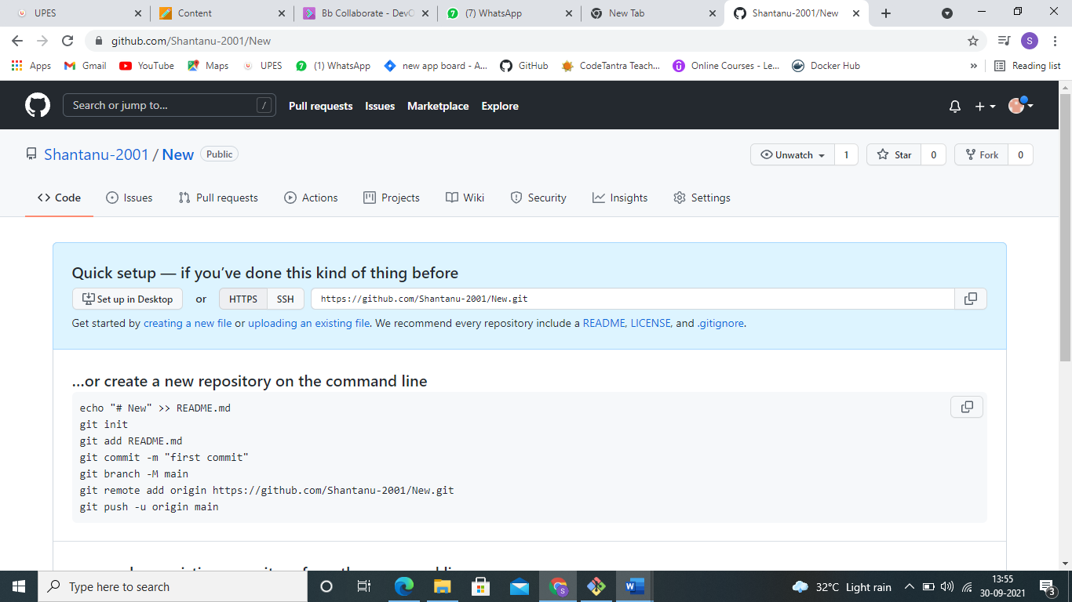

1. Pushing work to github

First we have to go back in the git terminal and then we have to reach to the repository which we want to push to git hub.

After reaching to the desired repository we need to type two command:-

**git remote add origin** [**https://github.com/Shantanu-2001/New.git**](https://github.com/Shantanu-2001/New.git)

**git push -u origin master**

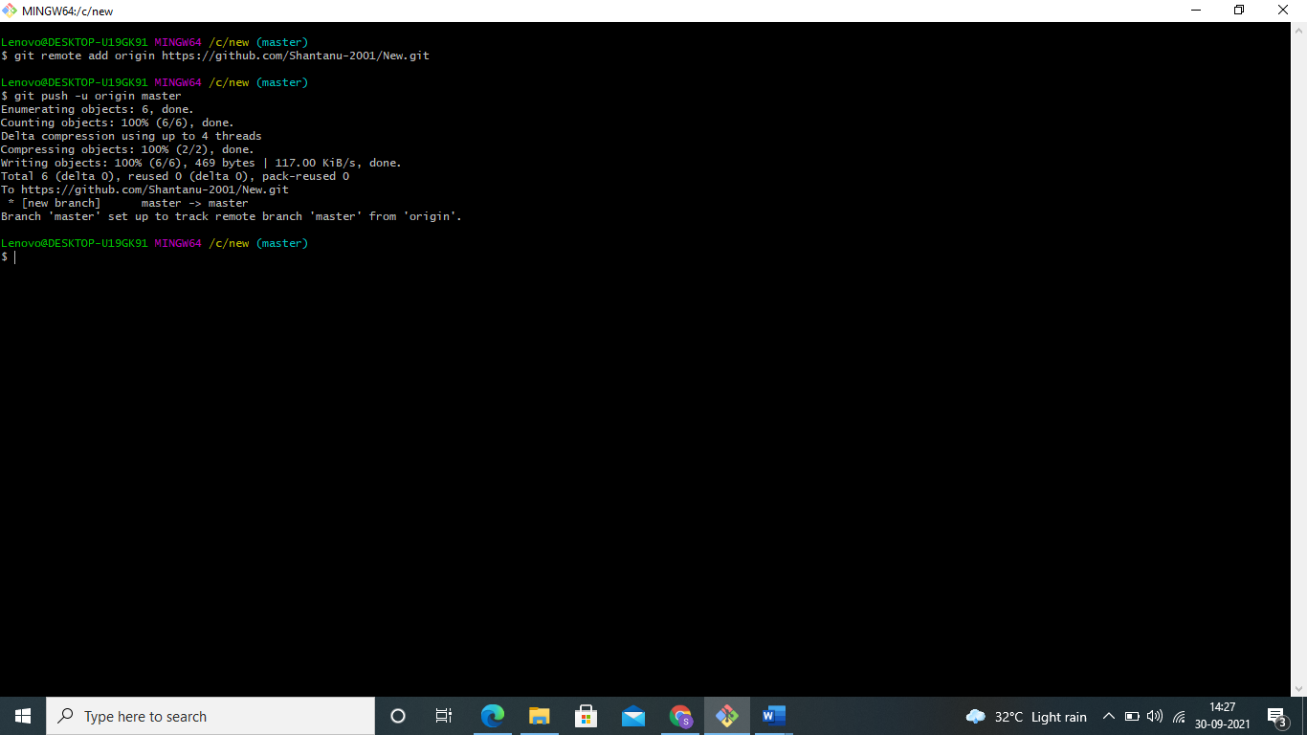

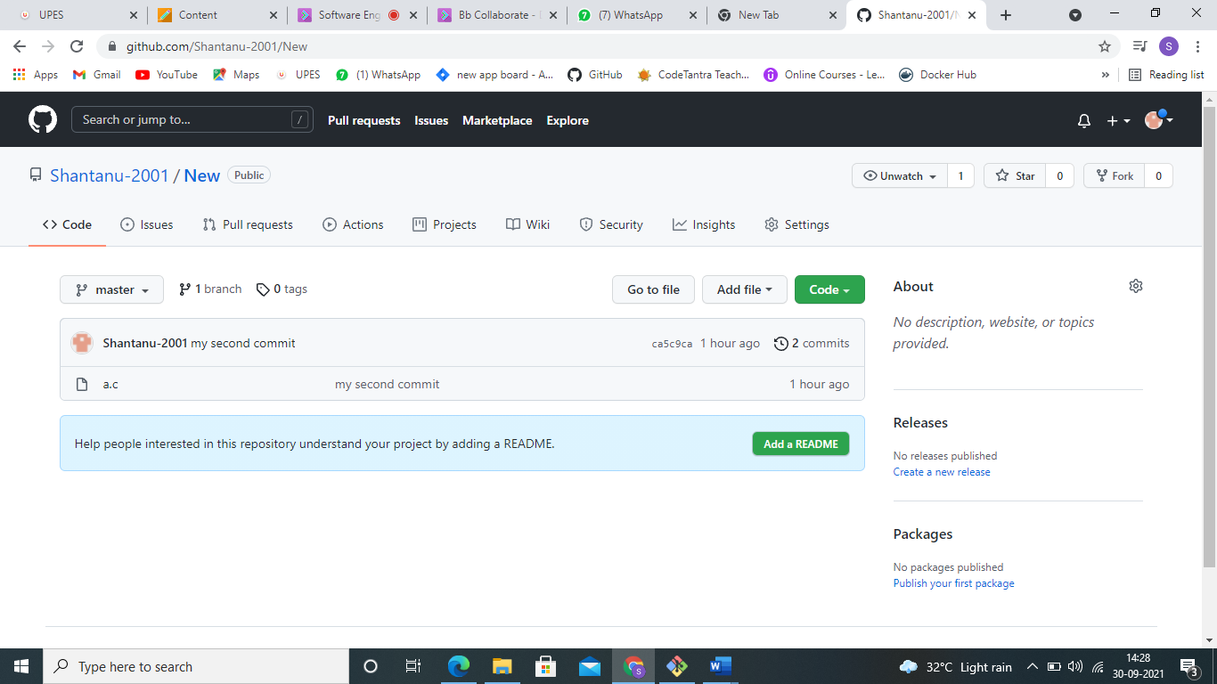

Finally the repository is pushed in github.